CO2 AT1
CSA0918:JAVA PROGRAMMING
M.DEEPIKA(192311027)
Normalising Customer Names Using Java String Handling

Topic: String Handling in Java

1. Problem Statement
An e-commerce platform stores customer names typed in through a checkout form. Because the form does not validate input strictly, the names that reach the database are often untidy - they may contain leading or trailing spaces, inconsistent upper/lower case letters, and accidental double spaces between first and last names (for example " rahul sharma" or "PRIYA verma "). Storing names in this raw form causes problems later, such as duplicate customer records, broken sorting/searching, and unprofessional-looking invoices or shipping labels. The goal is to normalise every name into a clean, consistent format - trimmed, single-spaced, and properly capitalised - without altering the original String object that was received from the form.

2. Strategy
Since java.lang.String is immutable, none of the built-in String methods can change a String object in place. Every method listed below returns a brand new String and leaves the original object exactly as it was received. The normalisation pipeline chains four steps together:
- trim() - removes leading and trailing whitespace from the name.
- replaceAll("\\s+", " ") - a regular expression that collapses any run of two or more spaces (or tabs) between words into a single space.
- toLowerCase() - converts the whole name to lower case first, so the capitalisation logic does not need to guess about mixed-case input like "PRIYA" or "KUMAR".
- StringBuilder - used to rebuild the name word by word, capitalising only the first letter of each word with Character.toUpperCase(). StringBuilder is mutable, so it is used deliberately here to avoid creating a new String object on every '+' concatenation inside the loop.
The result of the pipeline is returned as a new, clean String; the raw value the caller passed in is never touched.

3. Why String Immutability Matters
In Java, String objects cannot be modified after they are created. Methods such as trim(), toLowerCase() and replaceAll() only look immutable because of how they are used - in reality each call builds a new character sequence in memory and returns a reference to it. This has a few direct consequences for the name-cleaning task:
- Safety: the raw name coming from the checkout form can be logged, compared, or reused elsewhere in the code after normalisation without any risk that some other part of the program has silently changed it.
- Predictability: because Strings are immutable, they are safe to share across multiple threads (for example, several checkout requests being processed at once) without extra locking.
- String pool efficiency: identical String literals are cached and reused by the JVM. This only works because Strings cannot change - if they could, one part of the code changing a shared literal would corrupt it everywhere else it is used.
- Predictable hashing: Strings are commonly used as keys in HashMap (for example, mapping a normalised name to a customer record). If a String's contents could change after being inserted as a key, its hash code would change too and it would become impossible to find again.
This is also why StringBuilder is used inside the loop instead of ordinary '+' concatenation - StringBuilder is the mutable counterpart of String, purpose-built for cases where a value needs to be built up incrementally without generating a new object at every step.

4. Java Implementation
The class below contains a static normalize() method that performs the four-step pipeline described above, and a main() method that runs it against a small set of sample "dirty" names.
import java.util.*;

public class CO2AT1 {
public static String normalizeName(String name) {
// Remove leading and trailing spaces
String normalized = name.trim();
// Remove duplicate spaces
normalized = normalized.replaceAll("\\s+", " ");
// Convert to lowercase
normalized = normalized.toLowerCase();
// Split the string into words
String[] words = normalized.split(" ");
StringBuilder result = new StringBuilder();
// Capitalize the first letter of each word
for (String word : words) {

if (word.length() > 0) {

char firstLetter = Character.toUpperCase(word.charAt(0));

String remainingLetters = word.substring(1);

result.append(firstLetter)
.append(remainingLetters)
.append(" ");
}
}

return result.toString().trim();
}

public static void main(String[] args) {

Scanner sc = new Scanner(System.in);

System.out.println("Enter customer name:");

String originalName = sc.nextLine();

String normalizedName = normalizeName(originalName);

System.out.println("\nOriginal Name : " + originalName);
System.out.println("Normalized Name : " + normalizedName);

sc.close();
}
}

5. Steps to Compile and Run
- Save the file as NameNormalizer.java in a project folder.
- Open a command prompt / terminal and navigate to that folder.
- Compile the program using: javac NameNormalizer.java
- Run the compiled program using: java NameNormalizer
- The program prints each raw name next to its normalised version, followed by a short note confirming the original values were never modified.
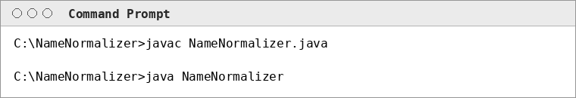

6. Output
The screenshot below shows the actual console output produced by running the program on the five sample names.
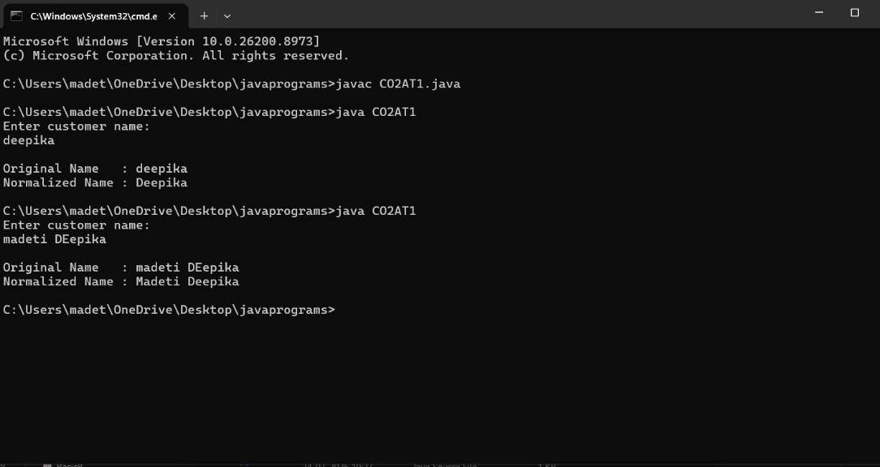

7. Conclusion
Using trim(), replaceAll() and toLowerCase() together gives a short, readable pipeline for cleaning up messy customer names, while StringBuilder handles the one part of the task (re-capitalising each word) that genuinely needs a mutable buffer. At no point is the original String object changed - every step produces a new object, which is the direct result of String immutability in Java. This makes the normalisation function safe to use anywhere in the checkout flow, since the caller's original input is always left intact for logging, auditing, or comparison.

